DEFENSIVE AND COMPETITIVE BIDDING
OVERCALLS (Style; Responses; 1/2 Level; Reopening)
Light at 1-level, normal at 2-level
Responses 2-level NF but CONSTR, other level F1
Raises acc LAW, fit-jumps on MAJ O/C
with opp O/C 2NT BAD/GOOD
In Bal pos 2NT 19-21 BAL
1NT OVERCALL (2nd/4th Live, Responses, Reopening)
2nd pos 15-18, resp. 1NT-opening
4th pos 11-14 BAL, not promising stopper; resp 1NT-opening system
After 2 Bids 2-suiter in unbid suits
JUMP OVERCALLS (Style, Responses, Unusual NT)
2-level and other level weak
in bal pos 10-15 HCP
2NT: 5/5 in lowest unbid suits; in bal pos 19-21 BAL
DIRECT AND JUMP CUE BIDS (Style, Respones, Reopen)
2-level: 2-suiter in highest and other unbid suit, weak or
strong, with passed Pd all ranges
VS. NT (vs. Strong / Weak, Reopening, PH)
X 15+, 2♣: both M;
2♦: 1M; 2♥♠: ♥♠+m 5⁺/4^{+,};2NT: both m
VS PREEMPTS (Doubles, Cue-bids, Jumps, NT bids)
X: T.O.
leaping Michaels
mod. Nonleaping Michaels (including i.e.: (3m) 4♣:om+M,
(3m) 4♦: both M )
VS. ARTIFICIAL STRONG OPENINGS (strg 1♣/♦)
X = info-X (1♣ p 1♦ X=♦, else like on 1♣)
1LEV NAT
1NT = ♣+♦
2LEV = MultiLandy (like vs. 1NT)
OVER OPPONENTS' TAKEOUT DOUBLE
1M-X-2♦♥ = Drury
Print date: 13.05.2010 Save date: 13 May 2010 File Name: input.doc
LEADS AND SIGNALS
OPENING LEADS STYLE
 |  | Lead |  |  |  |  |  |  | In Partner's Suit
Suit |  | 2nd/4th |  |  |  |  |  |  | 3rd/5^{th *}
NT |  | 2nd/4th |  |  |  |  |  |  | 3rd/5^{th *}
Subseq
*In raised PD suit ATT
In NT: H for deblock next H
LEADS
Lead |  | Vs. Suit |  |  |  |  |  |  |  |  |  |  | Vs. NT
Ace |  | A,Ax,AK(+)
King |  | K,Kx,KQ(+)
Queen |  | Q,Qx,QJ(+),AQJ(+) |  |  |  |  |  |  |  |  |  |  | same
Jack |  | J,Jx,J10(+),AJ10(+),KJ10(+)
10 |  | 10,10x,109(+)
9 |  | 9,H9x
Hi-x
Lo-x |  | xX xXx(+) 10Xxx(+) HXx HxxX(+)
SIGNALS IN ORDER OF PRIORITY
 |  |  |  | Partner's Lead |  |  | Declarer's Lead |  |  |  |  | Discarding
 |  | 1 |  | ATT |  |  | Length |  |  |  |  | Low=enc
Suit |  | 2 |  | Length |  |  | SP
 |  | 3 |  | SP
 |  | 1 |  | Length |  |  | 1. rev S-peter |  |  |  |  | Low=enc
NT |  | 2 |  | ATT |  |  | Length
 |  | 3 |  | SP |  |  | SP
Signals (including Trumps):
Basic: UDCA: Lo=ENC, Hi/Lo=Odd
special: NT: 2. trick rev smith peter
DOUBLES
TAKEOUT DOUBLES (Style, Responses, Reopening)
10+ M oriented
After 1NT and intervention T/O double
1st and 2nd DBL often T/O
SPECIAL; ARTIFICIAL AND COMPETITIVE (RE-)DOUBLES
T.O.-X up to 4♦ (or 4♥♠ if raised); 1♣ -4♦ -X = 4⁺/4⁺M
Responsive-X up to 3♠
Unlead-X on Opp.-Cuebid at 3+ LEV
Strength showing XX F to 2NT
International-Convention-Card
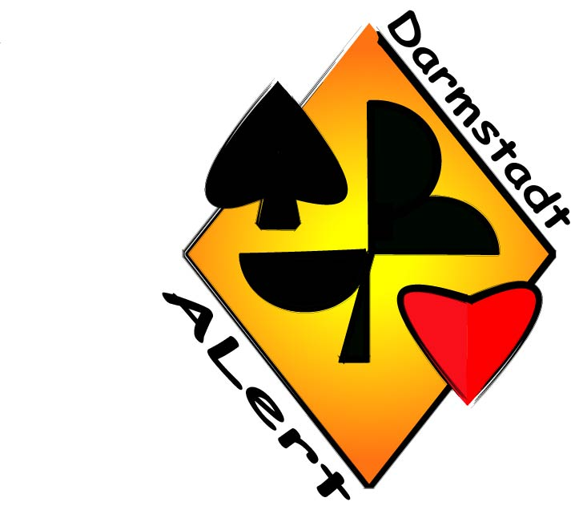
Category: |  |  | green
NCBO: | Germany |  |  |  |  |  |  | EVENT:
PLAYERS: |  |  |  |  | Anja Alberti
 |  |  |  |  | Fried Weber
SYSTEM SUMMARY
GENERAL APPROACH AND STYLE
5 card Majors 5 – 5 – 3 – 3
2/1 FG
1NT Opening: 15 – 17
2 over 1 Response: gameforcing
SPECIAL BIDS THAT MAY REQUIRE DEFENCE
2♣: FG any / 24+ NT
2♦: w2 MAJ / 22-23 NT
2♥ : weak-2-suiter 5⁺♥ + 4⁺minor (VUL: 5⁺/5⁺)
2♠ : weak-2-suiter 5⁺♠ + 4⁺minor (VUL: 5⁺/5⁺)
2NT: 20-21 NT
1♣ (p) 2♦: 5⁺♠ + 4⁺♥, 5-8
1♥♠ (p) 1NT: 6-12
SPECIAL FORCING PASS SEQUENCES
- after strength showing XX up to 2NT
IMPORTANT NOTES THAT DON'T FIT ELSEWHERE
PSYCHICS: rare

Opening Bids | tick if Artificial | Nr. Of Cards | Ne.-X through | DESCRIPTION | RESPONSES | SUBSEQUENT AUCTION | PASSED and O/C HAND BIDDING
1♣ |  | 3 | 4♦ | NAT | 1♦: 2⁺♦, no 4⁺M if less than FG; 1M: might have 5+♦ | After 1NT rebid: 2♣ 1.♦ wk 2. any INV; 2♦ any FG | INV m structure also after X
 |  |  |  | 11-22 | 2M: 5-8 6⁺; 2♣: 9⁺-11; 3♣ 7-9; 2NT: 0-6/12+ 5+♣ | After 2M: +1 ask shortness, +2 ask values
 |  |  |  | also with 3♣/3♦ | 1NT: 8-10; 2♦: 5-8 5⁺♠ /4⁺♥ | After 2♦: 2NT F1 3♣ ♦ MIN 5/4 5/5 3♥ ♠ MAX 5/4 5/5
1♦ |  | 3 | 4♦ | NAT; 11-22; | 2M: 5-8 6+; 2♦ 9-11; 3♦ 7-9; 3♣ 0-6/12+ 4+♦ | After 1NT rebid: 2♣ 1.♦ wk 2. any INV; 2♦ any FG | INV m structure also after X
 |  |  |  | also with 4♣/4♦ |  | After 2M: +1 ask shortness, +2 ask values
 |  |  |  | only 3 with 4-4-3-2
1♥ |  | 5 | 4♦ | NAT | Bergen/Jacoby raises | 1♥ -2♥ : =>Help suit trial | 2♦ : Drury, also after X
 |  |  |  | 11-22 | 3NT BAL 3♥ |  | Bergen/Jacoby also after X
1♠ |  |  | 4♦ | NAT | Bergen/Jacoby raises | 1♠ -2♠ : =>Help suit trial | 2♥ : Drury, also after X
 |  |  |  | 11-22 | 3NT BAL 3♠ |  | Bergen/Jacoby also after X
1NT |  |  |  | 15-17 | 2♣: nf STAY; 2♦♥: TRF; 3♣♦: INV | After TRF: break with 4+ | LEB after O/C 2♦♥♠
 |  |  |  |  | 2♠:a) INV BAL (no M) b) 6⁺m SI or WK c) FG [41]44
 |  |  |  |  | 3M: (3M1)[54] FG; 4♣:both M; 4♦♥ TRF;
 |  |  |  |  | 2NT: a) 5/5 ♣+♦ 1. to play 2. FG b) FG [31][54]
2♣ | X | - |  | 1. FG any | CTRL: 2♦ 0-1, 2♥ 2, 2♠ 3+ |  | 2♣ X pass: cards; XX: WK
 |  |  |  | 2. BAL 24+ | 2NT3♣♦♥: TRF ♣♦♥♠ |  | 2♣ xy X: WK
2♦ | X | - |  | 1. W2 M weak | 2/3M: P/C (2♥♠ poss nat); 2NT: INV+; 3m: F1; | After 2NT: 3♣♦ MIN ♥♠, 3♥♠ MAX ♠♥, | 2♦ X: pass 5+♦, XX ask M
 |  |  |  | 2. BAL 22-23 | 4♣: ask TRF to M; 4♦: ask M; 4M to play | After 2♠ - 3♣♦♥ (all ♥ WT answers) - 3♠ to play | 2♦ X: 2M3m NF; 2♦ 2/3M X: P/C
2♥ | x | 5 |  | 5+♥ 4+m weak | 2♠: NF , 2NT: INV+, 3♣: P/C, 3♦: F1 | After 2NT: 3♣♦ MIN, 3♥♠ MAX ♣♦ | after X: 2♠ 3♣♦ NF; XX ask m
 |  |  |  |  | 3♠:nat FG, 4m: SPL, 4♠: XKCBW, 5m: P/C
2♠ | x | 5 |  | 5+♠ 4+m weak | 2NT: INV+, 3♣: P/C, 3♦♥: F1 | After 2NT: 3♣♦ MIN, 3♥♠ MAX ♣♦ | after X: 3♣♦♥ NF; XX ask m
 |  |  |  |  | 4m♥ : SPL, 5m: P/C
2NT |  |  |  | 20-21 BAL | 3♣: RomexSTAY, 3♦♥: TRF M, 3♠: m STAY | After STAY/TRF: 4m often cond. RKCB m | NT Sys also applies after other strg
 |  |  |  | 5M poss. | 4♣: both M, 4♦♥:TRF, 4♠: to play |  | 2NT bids
3♣ |  | 6 |  | Pree | NS F, 4♦ cond. RKCB
3♦ |  | 6 |  | Pree | NS F, 4♣ cond. RKCB
3♥ |  | 6 |  | Pree | NS F, 4♣ cond. RKCB
3♠ |  | 6 |  | Pree | NS F, 4♣ cond. RKCB
3NT |  |  |  | Gambling | 4♣ P/C, 4♦ ask shortage | After 4♦: 4M: shortage 4NT: no shortage, 5m: short om
4♣ | x | - |  | 8/8.5 Tricks with ♥ | +1 Relay: cond. RKCB: 1. Step no side A
4♦ | x | - |  | 8/8.5 Tricks with ♠ | +1 Relay: cond. RKCB: 1. Step no side A | HIGH LEVEL BIDDING
4♥ |  | 6 |  | Pree |  | RKCBW (4130); 4m RKCB are conditional (1. Step = no interest);
4♠ |  | 6 |  | Pree |  | Voiddetecting RKCB after SPL.; Spiral-Scan after BW Answer; Mixed Cuebids; Josephine 5NT,
4NT |  |  |  | Both minors | nat | Ripo-Dipo after BW interference; Depo after interef. higher than 5-fitsuit, Voidwood

